**Practical No. 15**

**Aim:** Prepare a report on Latest Networking Technology in use.

**Abstract:**

The use of data systems to manage and provide digital resources through a computer network is known as network technology. A wide range of industries require computer hardware and system software to maintain networks, necessitating the hiring of network administrators.

As the demand for Ethernet and Wi-Fi has expanded dramatically over the years, networking technology has changed tremendously. Apart from being compatible with a variety of devices, Local area networks require to manage traffic getting generated from many other sources such as live streaming video, Network attached storage (NAS), Voice over IP (VoIP) , virtualization , Cloud and IoT devices and services have generated demand for additional bandwidth.

**Introduction:**

* **What is Wi-fi 6?**

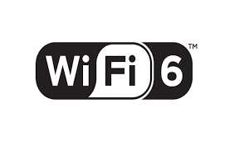

It is the next generation of Wi-fi. It will continue to link you to the internet in the same fundamental way. However, there are several additional technologies that can help speed up the process and make it more efficient.

**Performance:**

**How fast is Wi-fi 6?**

The short answer is 9.6Gbps, which is faster than wi-fi 5's 3.5Gbp

Both of these rates, 9.6 Gigabits per second and 3.5 Gigabits per second, are theoretical; you are unlikely to achieve them in the actual world. In the United States, the average download speed is 72 Mbps, which is less than 1% of the theoretical maximum speed.

However, the fact that Wi-Fi 6 has a higher theoretical speed limit than Wi-Fi 5 is still significant. The 9.6Gbps speed does not have to go to a single computer; instead, it may be shared across computers on the network, providing each device additional potential performance.

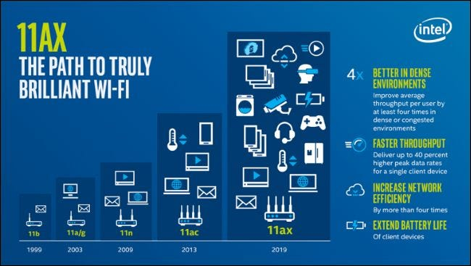

**Reliability:**

Wi-Fi 6 has a higher reliability rating than Wi-Fi 5. It has a latency reduction of up to 75%. It does this by more effectively managing network traffic. This implies faster game downloads, improved upload rates for streaming gaming, and more stable media multitasking for gamers.

**Security:**

* **Wi-Fi 6 also means better security!**

Last year, Wi-Fi started getting its biggest security update in a decade, with a new security protocol called WPA3. WPA3 makes it more difficult for hackers to crack passwords, and it renders certain data less usable even if they do.

Some modern devices and routers support WPA3, however it is not necessary. Because WPA3 is required for Wi-Fi 6 device certification by the Wi-Fi Alliance, most Wi-Fi 6 devices will almost certainly have it once the certification process begins.

**Prerequisites:**

Wi-Fi 6E devices will work with Wi-Fi 6 and older Wi-Fi standards, but you'll need a Wi-Fi 6E router and a Wi-Fi 6E client device to access the new 6GHz channels (meaning computers, phones, smart home devices, and other gadgets that support Wi-Fi 6E). That implies you'll need to update to a Wi-Fi 6E router even if you have a reasonably fresh Wi-Fi 6 router.

**Advantages:**

1. Increased access point capacity
2. Greater channel width
3. More efficient bandwidth sharing
4. Wi-Fi sleeping
5. Backwards compatibility

**Disadvantages:**

* 1. Expensive equipment/Peripherals
  2. Less Network Range

**Future Scope:**

It can deliver faster internet speeds by uniformly dispersing bandwidth among different goods, as well as support IoT (Internet of Things) applications that will be useful in the future. Overall, Wi-Fi 6 is the communications equivalent of 5G.